One of the best ways to visit Santander is by bus; the city offers a wide variety of Bus lines that connect every single part of the city efficiently. Visitors can benefit from two different companies, one connecting the airport to the city and another one interconnecting the city itself.
The first one takes 15 min and connects Santander’s airport to the centre of the city. The final stop is at the Bus Station. After arriving, many local buses stop by Jesús de Monasterio Street, an adjacent street just at the other side of the tunnel, and continue
https://turismo.santander.es/organiza-viaje/moverse-por-santander
How to arrive to Santander?
To get to the city center you have different options:
By bus: there are buses from the airport to Santander’s bus station from 7:30 every hour to 22:30. The price is 2,90€. For going back to the airport the schedule is from 7:00 every hour to 21:00, 21:45.
Taxi/Cabify:
- Cabify offers its service all around the city as well as in the airport. You can book a Cabify via app; the cost depends on the time and the location. It operates in a similar way to Uber.
- Taxis are another way of moving around the city. You can take them at the airport, at the university and at the train and bus stations
How to get to the University of Cantabria?
By bus:
Usually, the price for a ticket is 1,30€, but you can buy the Santander bus card TUS and pay the ticket 0,66€. The card costs 1€, it is rechargeable and the minimum amount to put on it is 6€. You can get it in almost every Tobacco shop “Tabacos”.
7C2 line/7C1Line.
From the Sardinero: take the bus at the bus stop Plaza de Italia 3 and get off at Los Castros 62.
From the city center: take the bus at one of these bus stops: Ayuntamento, Catedral, or Jardines de Pereda. Get off at Los castros 62.
Going back to Plaza de Italia/City Centre: 7C1 provides the same itinerary but in the oppsite direction, so it’s the best way to go back to your hotels or attend any of the social events.

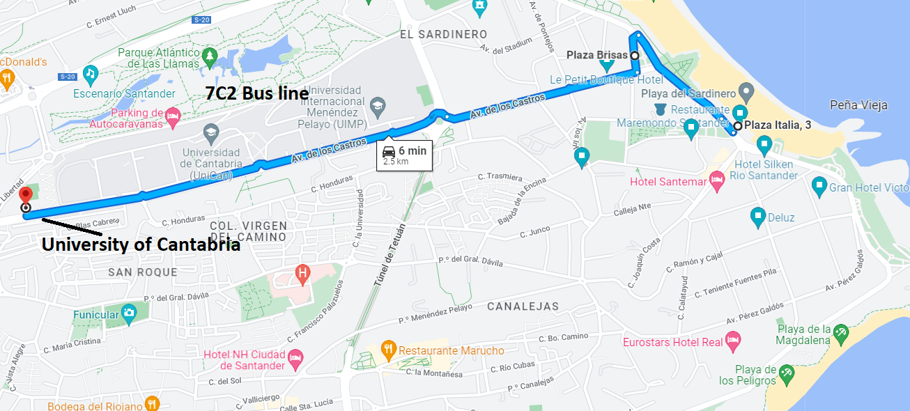
Be aware that 7C2 Bus line does not go through Plaza de Italia until 9:00 am. If you stay at “El Sardinero” zone you should take line 4 instead that stops by “Plaza de Italia, 3” and leaves you at “Rectorado”, very close to the Economics Faculty.
The following link includes the TUS Santander app that you can download. It offers all the information about bus lines’ schedules.
https://play.google.com/store/apps/details?id=com.celapps.tus&hl=en&gl=US
By bicycle:
In Santander, there is a cheap bicycle renting service which costs 2€ to get the bicycle and 0,63€/hour except the first one. Additionally, there is a deposit of 25€.
Bikes are available in these locations:
To go to the University of Cantabria you take the bicycles in these spots:
- Plaza de Italia.
- 2ª Playa del Sardinero.
- Jardines de Pereda.
- Pz. Numancia-Alameda.
You can leave your bicycle just outside of the Economics Faculty where the IFERA congress will take place. In order to use the service you need to have a debit/credit card. The following link offers more information about this service:
http://www.tusbic.es/Abonate/Abono-diario/Una-inscripcion-economica-y-practica
By renting a car:
- Guppy is a renting car service available in Santander; users can park everywhere in the Guppy Zone without worrying about paying parking taxes. You can consult its prices clicking on the following link.
- https://www.guppy.es/en/prices/

How to get to Golf Mataleñas?
On Tuesday 21, there will be a meeting at “Restaurante Golf Mataleñas”. You can go by walking or by taking the Bus Line 1 that leaves you near the restaurant. This line goes from the city centre to “El Sardinero”.


